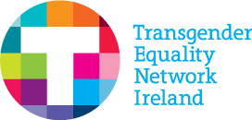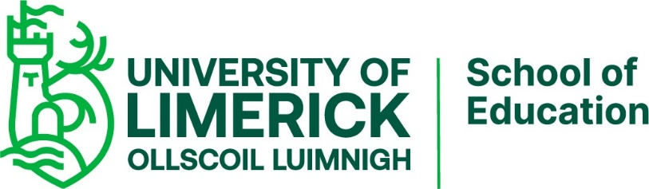
Media Contacts:
Dr. Aoife Neary, University of Limerick | aoife.neary@ul.ie
Éirénne Carroll, CEO, TENI | eirenne@teni.ie
Vanessa Lacey, Health & Education Manager, TENI | vanessa@teni.ie
Hannah Solley, Family Support & Education Officer, TENI | hannah@teni.ie

For Immediate Release
University of Limerick, Irish Research Council, Transgender Equality Network of Ireland (TENI), and Collaborative Research Fellowship for a Responsible and Innovative Europe (CAROLINE) celebrate the release of the Gender Identity and Gender Expression E-Resource for Second-level Schools (https://www.ul.ie/gender-identity-school-resources/)
(December 8, 2020) The Transgender Equality Network of Ireland,in partnership with the University of Limerick and co-funded by the Irish Research Council and Marie Sklowdowska-Curie Actions CAROLINE programme, are proud to share the release of the Gender Identity and Gender Expression E-Resource for Second-level Schools. This e-resource has been designed to support second-level school staff in learning about gender identity and expression and ensuring that schools are inclusive of young people who are trans and gender diverse.
The e-resource is divided into sections with accompanying worksheets in a workbook that can be completed in multiple sittings. Topics explored in this e-resource are: silence and invisibility, uniforms, bathrooms, sports, names and pronouns, bullying, curriculum, coming out, steps to take in facilitating a young person’s transition and support groups. Grounded by findings from a two year long research project with trans youth, parents, educators and wider education stakeholders, each section provides useful short educational videos, impactful quotes from trans and gender diverse young people, suggested actions for change as well as links to wider supports and resources.
The e-resource is designed to work in tandem with the school-based training and supports offered by TENI. Ideally, this e-resource would be completed by individual second-level school staff, especially those working directly with trans and gender diverse students, and then staff would come together as part of a team or whole-school exercise to discuss further and develop an action plan. This resource and the research project amplify TENI’s dedicated work with young people, families and schools. We hope that the materials provided, along with the research, and training by TENI are foundational to building supportive schools that see trans and gender diverse students succeed in all facets of education.
This resource has arisen from a two year research project exploring the experiences of trans and gender diverse youth in second-level schools in Ireland. This research was a collaboration between the School of Education at the University of Limerick and the Transgender Equality Network Ireland. It was co-funded by the Irish Research Council and Marie Skłowdowska-Curie Actions as part of the “Collaborative Research Fellowships for a Responsive and Innovative Europe” (CAROLINE) programme.
Hannah Solley, Family Support and Education Officer at TENI and partner on the e-resource development team, and Vanessa Lacey, Health and Education Manager at TENI said:
“TENI are grateful to Dr Ruari McBride for undertaking this research project and to all of the participants without whom this research wouldn’t have been possible. We would like to thank Dr Aoife Neary for all her hard work and support in creating this resource. TENI are also thankful to the CAROLINE programme, the Irish Research Council and the University of Limerick for making it possible. The research findings directly correlate with experiences that TENI encounters through our work. This confirms that a deeper level of understanding, awareness and engagement is needed from the education sector in order for trans and gender diverse students to feel respected and accepted. We understand that in order for students to feel supported, schools also need support, and that is why this e-resource is such a fantastic initiative. A perfect opportunity for proactive engagement and to learn practical, helpful information.”
Dr Aoife Neary, Principal Investigator and Academic Mentor on the research project and e-resource development team, said:
“We are very thankful to the CAROLINE programme for enabling the development of this e-resource. The research from which this e-resource arises confirms unequivocally that schools need supports in order to ensure that trans and gender diverse young people are included and feel like they belong at school. This is a comprehensive, proactive e-resource that responds to this need, providing an accessible, open-access platform through which teachers and school leaders can learn about gender identity and gender expression and support trans and gender diverse students”.

View the Gender Identity and Gender Expression E-Resource for Second-level Schools on the web here:
https://www.ul.ie/gender-identity-school-resources/

For learning more about the research, and training the Transgender Equality Network of Ireland provide visit TENI’s website here:
https://www.teni.ie/

